Ari Ne'eman
 | DEPARTMENT OF HEALTH & HUMAN SERVICES | Centers for Medicare & Medicaid Services
 | FEB 4 2015 | Administrator  Washington, DC 20201

President
Austistic Self Advocacy Network P.O. Box 66122
Washington, DC 20035
Dear Mr. Ne'eman:
Thank you for your letter in which you urge the Centers for Medicare & Medicaid Services (CMS) to clarify that state Medicaid agencies cannot require that individuals receive services for the treatment of autism spectrum disorder (ASD) in clinical or facility-based facilities. You state that the provision of services to treat individuals with ASD must be furnished in the home, school, or other locations in the community in order to satisfy the community integration mandate in the Olmstead v LC (Olmstead) Supreme Court decision and the Americans with Disabilities Act (ADA).
I understand the importance of serving all individuals with disabilities, including Medicaid beneficiaries, in the most integrated settings that are appropriate to support their needs. Since the enactment of the ADA and the decision in the Olmstead case, CMS has issued guidance in support of community integration in the Medicaid program, such as our final regulation governing home and community-based services (HCBS). The regulation sets forth our requirements for ensuring that home and community-based services under a section 1915(c) waiver program or a section 1915(i) or 1915(k) state plan program are delivered in settings that meet our HCBS settings criteria.
The CMS has an important role in reminding states of their Olmstead and ADA obligations related to the Medicaid program. This includes reminding states that compliance with the Medicaid program does not equate to compliance with the ADA. The interpretation and enforcement of the integration mandate of Title II of the ADA and the Olmstead decision are within the authority of the U.S. Department of Justice. Guidance from the Department of Justice concerning compliance with the ADA and the Olmstead decision is available at: http://www.ada.gov/olmstead/q&a_olmstead.htm. The HHS Office for Civil Rights also has enforcement authority concerning HHS-funded entities and entities conducting health care and social services.
We appreciate your input and support for our July 7, 2014 informational bulletin on services to treat ASD. I hope that more Medicaid-eligible individuals will now gain access to medically-necessary services. Please share this response with the other organizations that cosigned your letter.

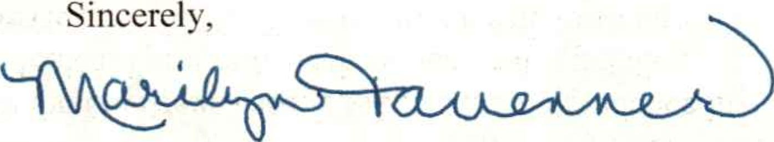
Marilyn Tavenner

