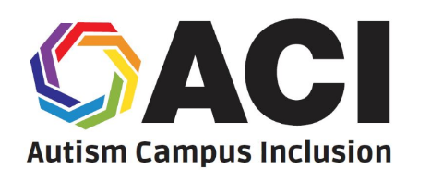
Autism Campus Inclusion (ACI)
Summer Leadership Academy
__________________________________________________________________________________________

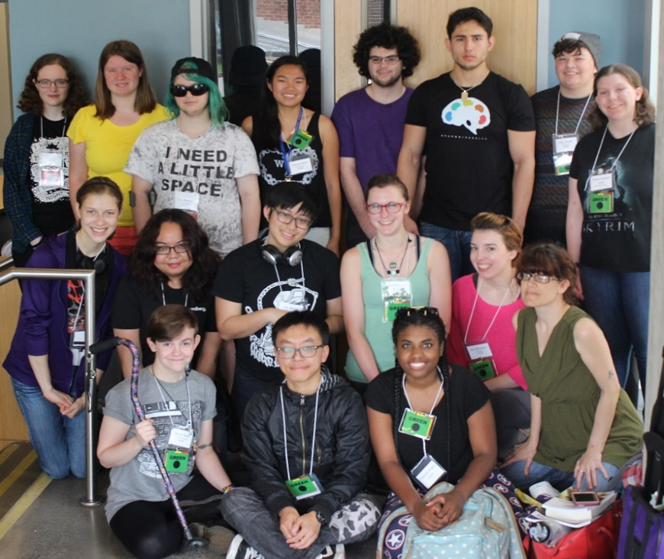
What is the Autism Campus
Inclusion (ACI) Leadership Academy?
The Autism Campus Inclusion (ACI) Summer
Leadership Academy, a project of the Autistic
Self Advocacy Network (ASAN), helps
autistic college students learn how to make their schools better for people with disabilities. ACI
participants learn about making student groups,
understanding disability policy, and talking to
people in the government. After the Academy,
students get help from ASAN to meet their
advocacy goals at their college.
ASAN pays for travel and rooms for
all Academy students.

When and where will the Leadership Academy take place?
The ACI Summer Leadership Academy will take place in Washington, D.C., from June 10th to June 17th, 2017.

Can I participate in ACI?
To be a part of ACI, you must:
• Be on the Autism Spectrum (it is okay if you do not have an official diagnosis)
• Be a student at a college, and have at least one year left at college before you graduate
• Live in one of the 50 states or the District of Columbia, Puerto Rico, or Canada

How do I apply?
The application for the ACI Summer Leadership Academy is on the ASAN website (autisticadvocacy.org). You can find it by typing “ACI 2017” into the search bar. Applications are due on Sunday, February 19th, 2017. To send your finished application or ask questions about ACI, please email Reid Caplan at rcaplan@autisticadvocacy.org

ACI is made possible with help from:

