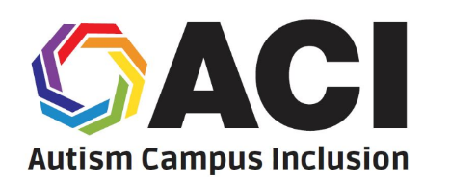
Autism Campus Inclusion (ACI)
Summer Leadership Academy
__________________________________________________________________________________________

What is the Autism Campus
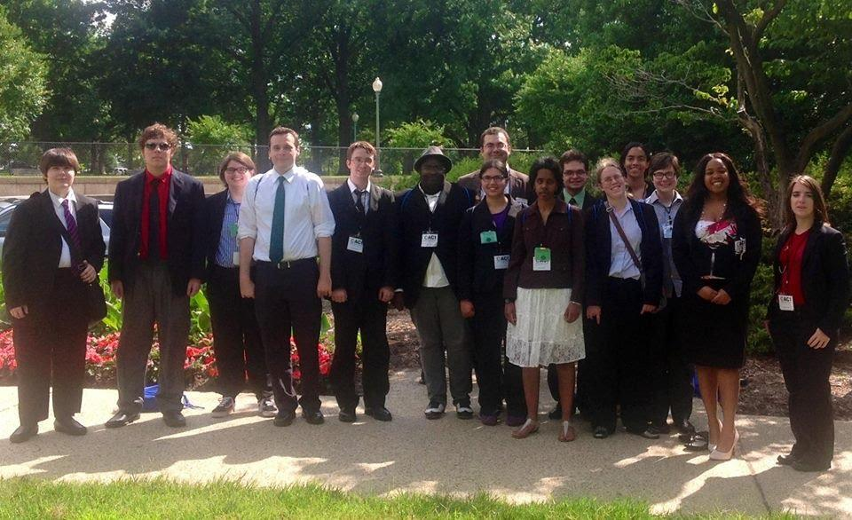
Inclusion (ACI) Leadership Academy?
The Autism Campus Inclusion (ACI) Summer
Leadership Academy, a project of the Autistic
Self Advocacy Network (ASAN), helps
Autistic students learn to make their college campuses better for people with disabilities. ACI
participants learn about making student groups,
understanding disability policy, and talking to
people in the government. After the Academy,
students get help from ASAN to meet their
advocacy goals at their college.
ASAN pays for travel and rooms for
all Academy students.

When and where will the Leadership Academy take place?
The ACI Summer Leadership Academy will take place in Washington, D.C., from June 16th to June 23rd.

Can I participate in ACI?
To be a part of ACI, you must:
• Be on the Autism Spectrum
• Be a student at a college, and have at least one year left at college before you graduate
• Live in one of the 50 states, the District of Columbia, or Puerto Rico

How do I apply?
Applications for the ACI Summer Leadership Academy are posted on the ASAN website. You can download an application and fill it out on your computer. Finished applications are due by Sunday, February 25th. To send your finished application or ask questions about ACI, please email Reid Caplan at rcaplan@autisticadvocacy.org

