Tips for filming:
- Pick a quiet place. The audio is the most important part.
  - Try to be within a few feet of whatever you’re filming with.
  - If one is available, please use a microphone.
- If you feel comfortable doing so, look directly at the camera and set the camera at eye height on a tripod or a steady surface. A stack of books works great!
  - Stand or sit in front of a background that isn’t too cluttered. You want people to focus on you, so keep the background as simple and uncluttered as possible.
  - Don’t sit or stand directly in front of a wall. Some space creates depth, which makes the shot better.
  - Position yourself centrally in the frame and about two feet back from the camera. The bottom of the camera should be in line with your chest.
- Shoot in a horizontal position
  - 16x9 for you tech types!
  - If using a phone, the picture should fill the whole screen. See below for an example.
- Make sure you are well lit.
  - Please do not film with your back to a window or bright light.
  - Experiment by moving around a bit and try a few angles to get the best light on your face.
  - Watch out for mirrors/reflective surfaces (like pictures on walls) in the background.
  - If using a light - be careful not to be too close to a white or light-colored wall, the light will bounce back and cause issues for the camera.
- You don’t have to jump right in - film 4 to 5 seconds of silence at the beginning before you speak.

Tips for audio:
- No equipment? No problem: Phones work great for this
  - every iPhone has an app pre-downloaded called “Voice Memos” that will allow you to record and send a file via email
- Pick a quiet place. Close doors, silence phones, and let everyone know you’re recording!
  - If one is available, please use a microphone.
- Hold whatever you’re recording with close to you.
  - If it’s a phone, try placing it like you’re talking to someone on speaker phone.
  - If you are an AAC user, try placing the recorder 6 to 12 inches from the device’s speaker.
- Take it slow! If you’re using a script, no need to rush through it.
  - You can speak in your regular voice, too.
- Record 4 to 5 seconds of silence at the beginning before you speak.

However, these are just suggestions. If they won't work for you - for example, if you don't have a blank wall - please consider submitting anyways. We'd love to hear from you and we appreciate you taking the time to record!

Technical specs if using a non-phone camera such as a DSLR:
- 1920 x 1080
- 30 fps

Examples:

Position yourself centrally in the frame and about two feet back from the camera. The bottom of the camera should be in line with your chest.
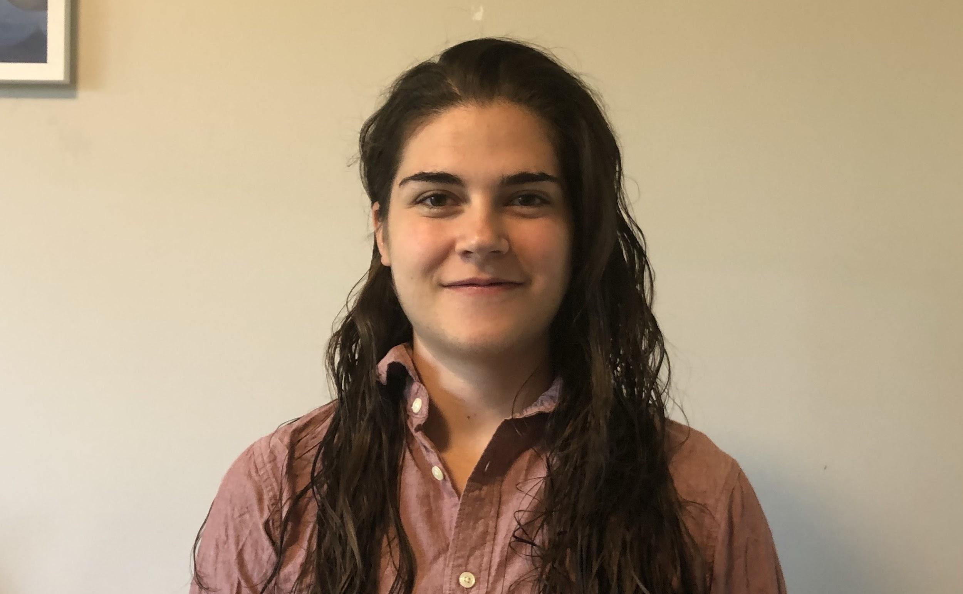

- Too far away - feels impersonal and awkward
- Just right!
- Too close - a little intimidating!
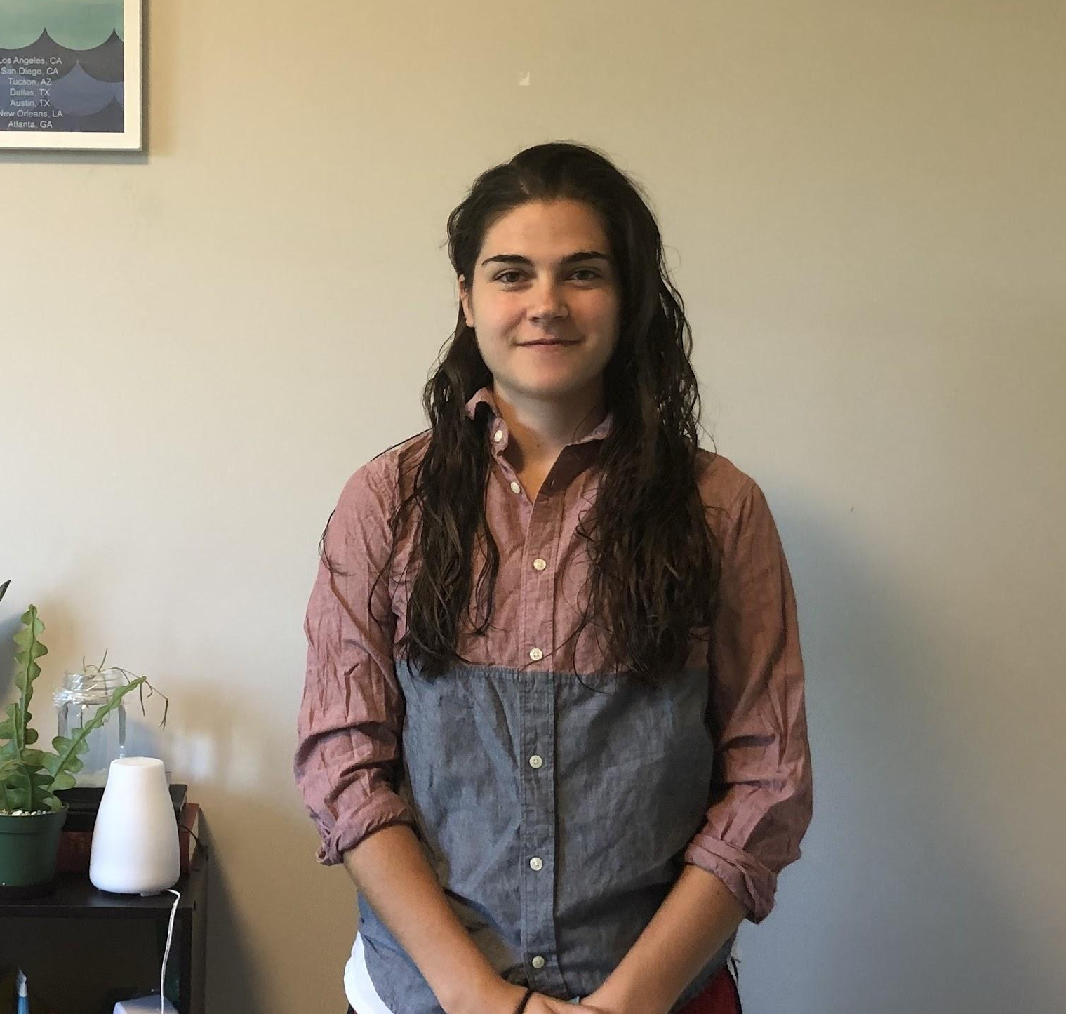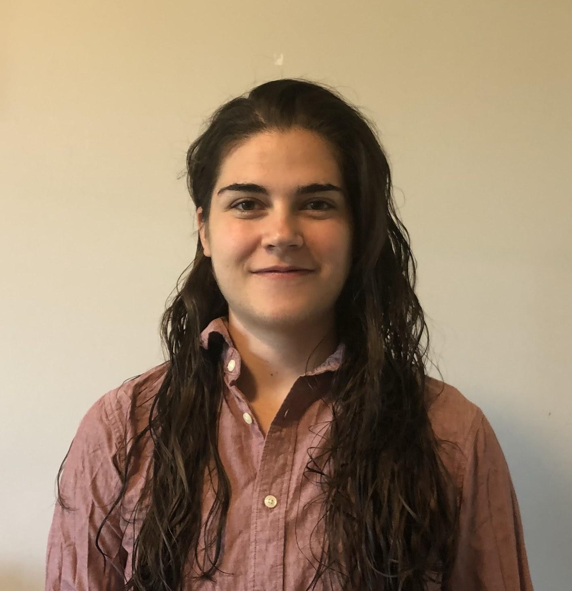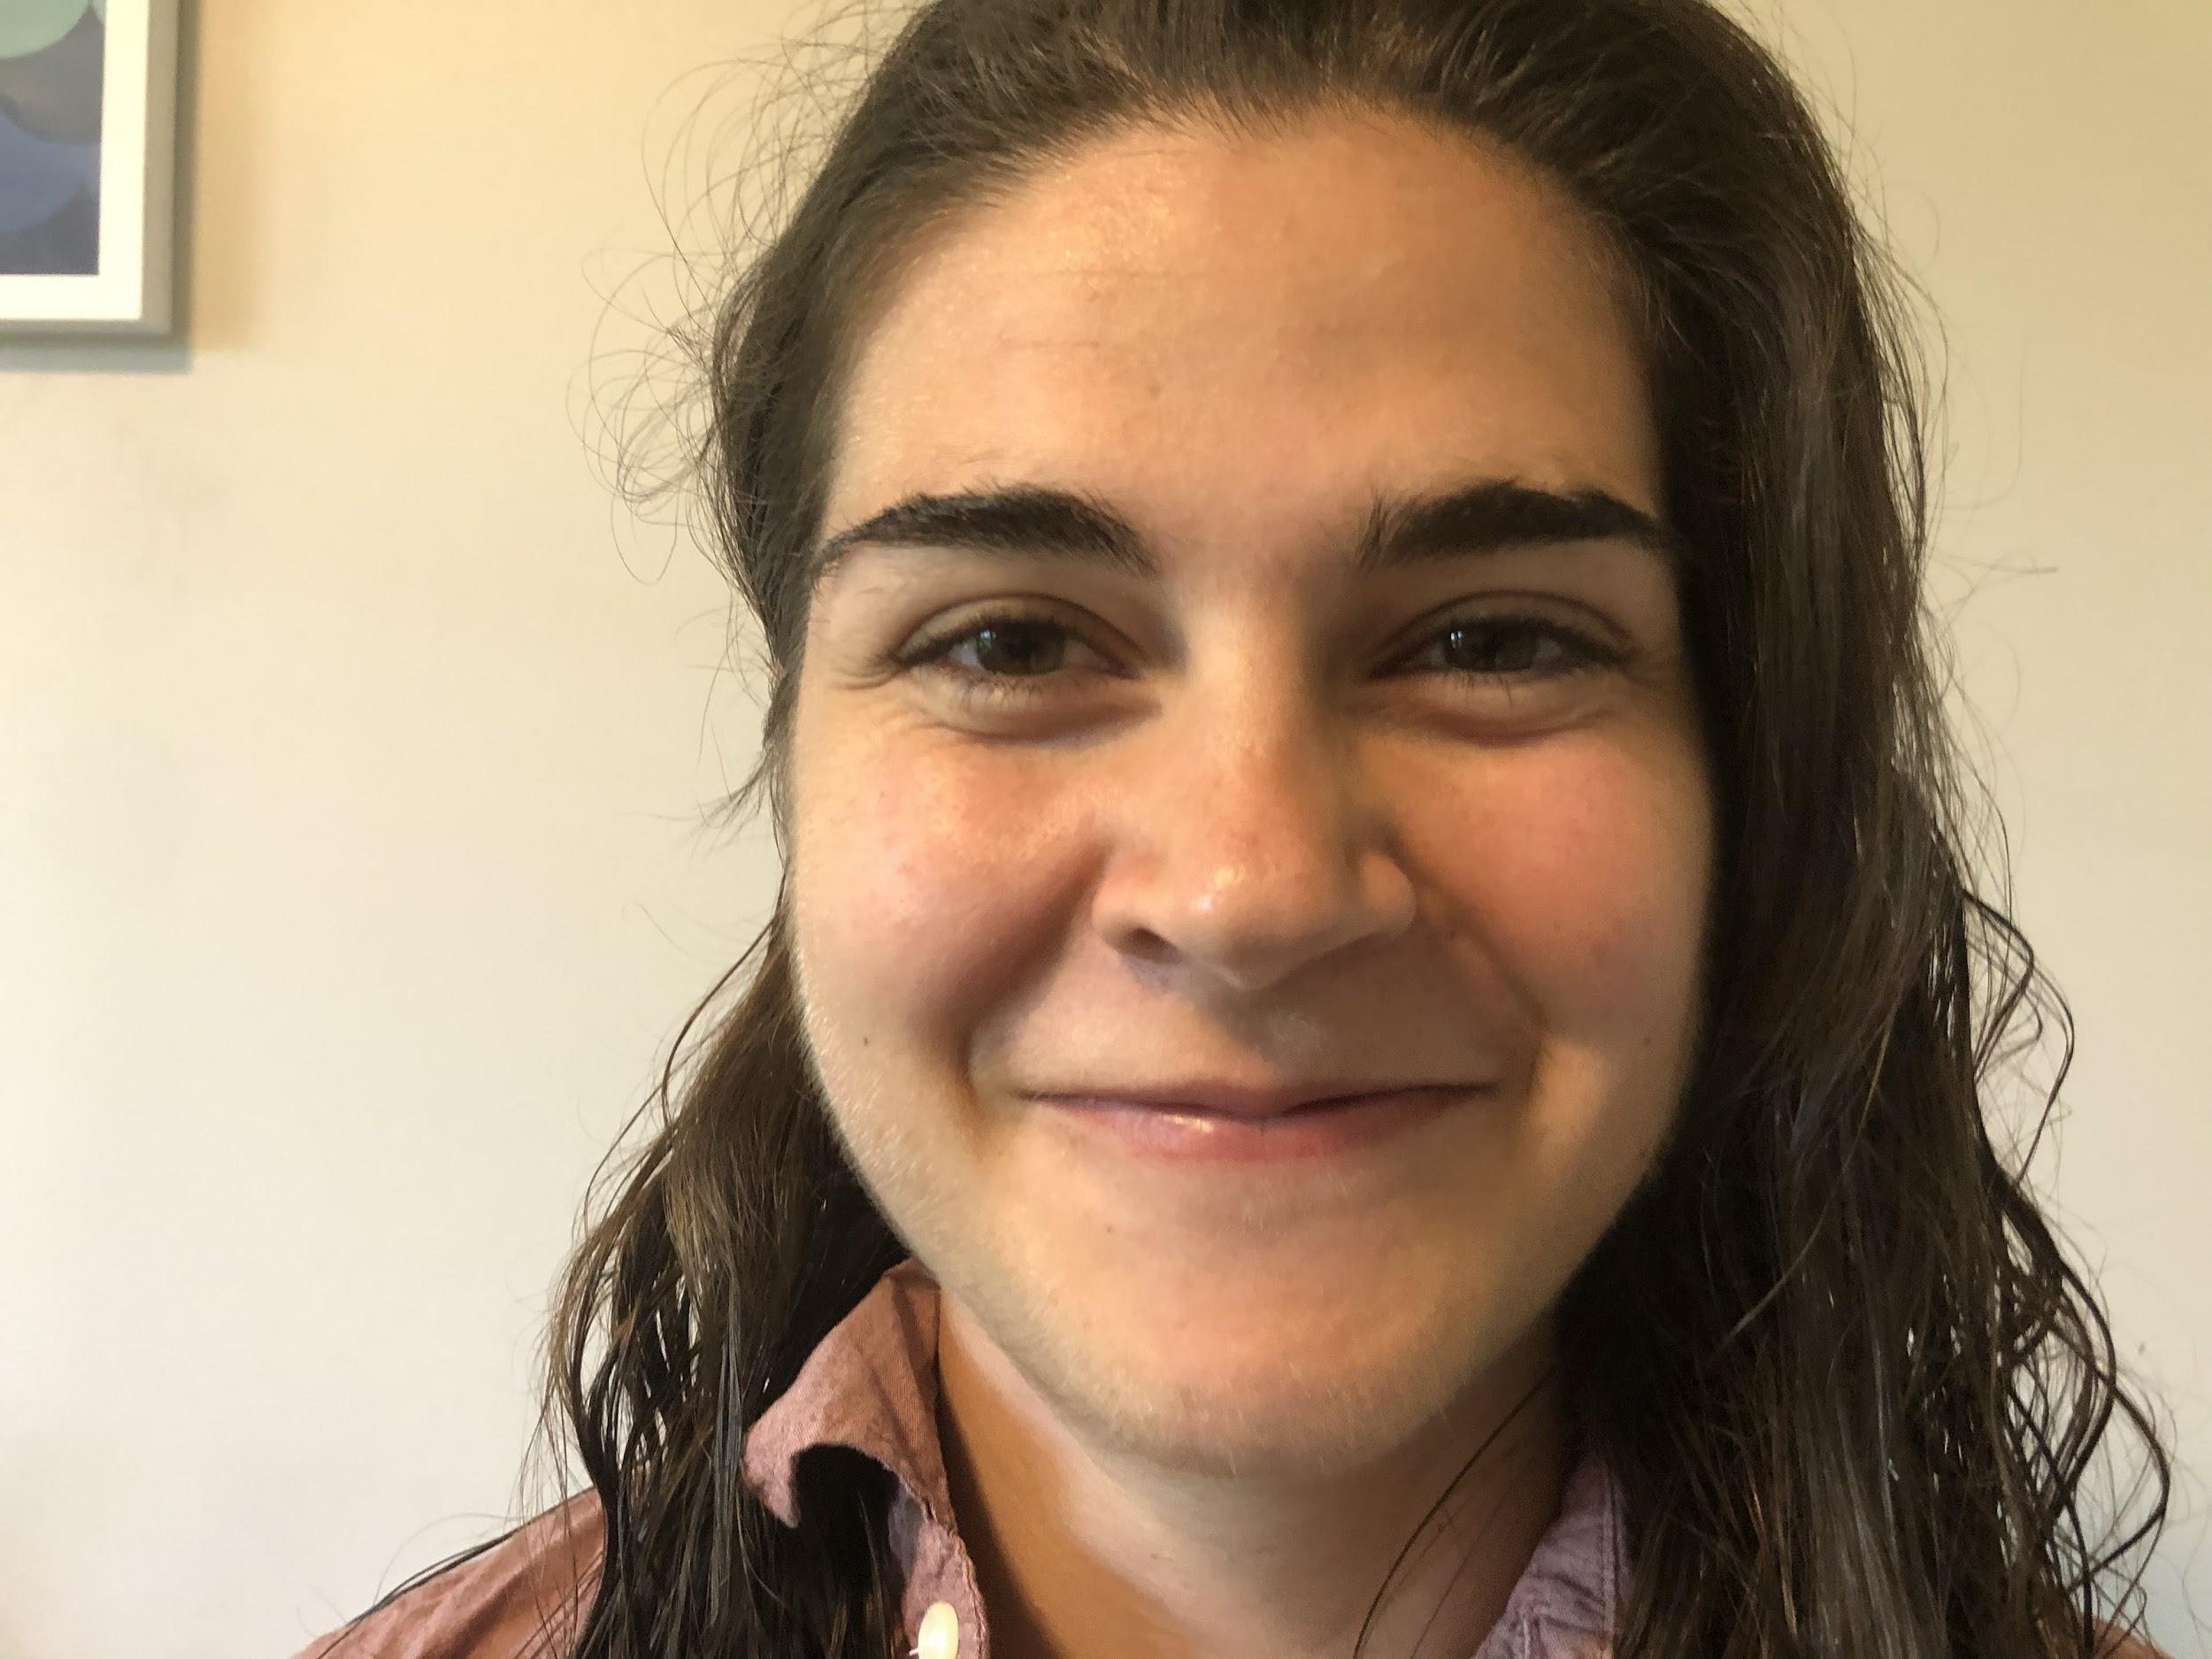

Leave enough room above your head - your eyes should be in line with the top of two imaginary lines dividing the frame into 3.

